Jarrod Venter

STB16JV9306045062082  
MCSD C# FINAL APPLICATION

Technical Manual

CTUCare Applicaton



Contents

Introduction 3

MainWindow (Splash Screen) 4

C# 4

XAML 5

Login 5

C# 6

XAML 7

Home 8

C# 8

XAML 9

Add User 10

C# 10

XAML 11

History 12

C# 12

XAML 16

Accounts 18

C# 18

XAML 22

Information 24

C# 24

XAML 25

Appointments 26

C# 26

XAML 27

New Appointment 28

C# 28

XAML 32

Open Appointments 34

C# 34

XAML 46

New Patient 48

C# 48

XAML 50

New Procedure 51

C# 51

XAML 52

New Medicine 53

C# 53

XAML 54

New Doctor 55

C# 55

New Medical Aid Company 56

C# 56

XAML 57

PatientToken.cs 58

Update.cs 58

UserType.cs 59

Database Diagram 60

Error Report 61

Error 1 61

Solution 1 61

Error 2 62

Solution 2 62

Error 3 62

Solution 3 63

Conclusion 63

# Introduction

When starting out this application, there was a heavy emphasis on ensuring that one followed the planning manual due to the sheer size of the application. Multiple windows were planned as well as an extensive database that would require strong integration.

One element of variability (where one was unlikely to follow their own plan) that was likely to come through was for the appointment system which had been given absolutely no guidelines and was up to the interpretation of the programmer

# MainWindow (Splash Screen)



## C#

using System.Threading.Tasks;

using System.Windows;

namespace CTUCare

{

/// <summary>

/// Interaction logic for MainWindow.xaml

/// </summary>

public partial class MainWindow : Window

{

public MainWindow()

{

InitializeComponent();

splashScreenStart();

}

//Logic for the progressBar to load for 2 seconds

private async void splashScreenStart()

{

loader.Value = 0;

loader.Maximum = 100;

for (int i = 0; i < 101; i++)

{

await Task.Delay(5);

loader.Value += 1;

}

Login initialize = new Login();

initialize.Show();

this.Close();

}

}

}

## XAML

<Window x:Class="CTUCare.MainWindow"

xmlns="http://schemas.microsoft.com/winfx/2006/xaml/presentation"

xmlns:x="http://schemas.microsoft.com/winfx/2006/xaml"

xmlns:d="http://schemas.microsoft.com/expression/blend/2008"

xmlns:mc="http://schemas.openxmlformats.org/markup-compatibility/2006"

xmlns:local="clr-namespace:CTUCare"

mc:Ignorable="d"

WindowStyle="None" Background="White" BorderBrush="White"

WindowStartupLocation="CenterScreen"

ResizeMode="NoResize" Height="199.2" Width="402.133" BorderThickness="3">

<Grid Background="#FF3699F1" Margin="0,0,0.2,0.4">

<Grid.RowDefinitions>

<RowDefinition/>

</Grid.RowDefinitions>

<Rectangle HorizontalAlignment="Left" Height="102" Margin="39,46,0,0" VerticalAlignment="Top" Width="90">

<Rectangle.Fill>

<ImageBrush ImageSource="Images/Picture4.png"/>

</Rectangle.Fill>

</Rectangle>

<TextBlock x:Name="textBlock" HorizontalAlignment="Left" Margin="220,96,0,0" TextWrapping="Wrap" Text="CTU Care" VerticalAlignment="Top" Height="75" Width="159" Foreground="White" FontSize="24" FontFamily="SnasmW00-Regular"/>

<ProgressBar x:Name="loader" HorizontalAlignment="Left" Height="22" Margin="220,126,0,0" VerticalAlignment="Top" Width="128" BorderBrush="White" Background="White" Foreground="#FF3699F1"/>

</Grid>

</Window>

# Login

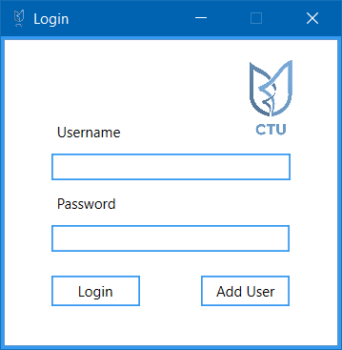

## C#

using System;

using System.Linq;

using System.Windows;

namespace CTUCare

{

/// <summary>

/// Interaction logic for Login.xaml

/// </summary>

public partial class Login : Window

{

public Login()

{

InitializeComponent();

}

private void btnLogin_Click(object sender, RoutedEventArgs e)

{

ValidateCredentials();

this.Close();

}

AddUser newUserWindow = new AddUser();

private void btnAddUser_Click(object sender, RoutedEventArgs e)

{

try

{

newUserWindow.Show();

}

catch (Exception)

{

AddUser newUserWindow = new AddUser();

newUserWindow.Show();

}

}

Home newHome = new Home();

private void ValidateCredentials()

{

string userUserName = txtUserName.Text;

string userPassword = txtPassword.Password;

var userList = CTUCareDB.Instance.Users.ToList();

var dbUser = userList.Find(x => x.Username == userUserName);

//1 for admin user, 2 for regular user

int adminUser = 1;

if (dbUser != null)

{

if (dbUser.Password == userPassword)

{

//Acts as a token for the users

if (dbUser.IsUserAdmin == adminUser)

{

UserType.UserKind = 1;

}

else

UserType.UserKind = 2;

try

{

newHome.Show();

}

catch(Exception)

{

Home newHome = new Home();

newHome.Show();

}

}

}

}

}

}

## XAML

<Window x:Class="CTUCare.Login"

xmlns="http://schemas.microsoft.com/winfx/2006/xaml/presentation"

xmlns:x="http://schemas.microsoft.com/winfx/2006/xaml"

xmlns:d="http://schemas.microsoft.com/expression/blend/2008"

xmlns:mc="http://schemas.openxmlformats.org/markup-compatibility/2006"

xmlns:local="clr-namespace:CTUCare"

mc:Ignorable="d"

Title="Login" Height="300" Width="300"

Icon="images/picture5.png" BorderThickness="3" BorderBrush="#FF3699F1"

ResizeMode="CanMinimize">

<Grid>

<Grid.ColumnDefinitions>

<ColumnDefinition/>

</Grid.ColumnDefinitions>

<TextBox x:Name="txtUserName" Height="23" Margin="39,95,39.6,0" TextWrapping="Wrap" VerticalAlignment="Top" BorderBrush="#FF3699F1" BorderThickness="1.5"/>

<Label x:Name="label" Content="Username" HorizontalAlignment="Left" Margin="39,64,0,0" VerticalAlignment="Top" Width="83"/>

<Label x:Name="label_Copy" Content="Password" HorizontalAlignment="Left" Margin="39,124,0,0" VerticalAlignment="Top" Width="83"/>

<PasswordBox x:Name="txtPassword" Margin="39,155,40,0" VerticalAlignment="Top" RenderTransformOrigin="0.5,0.5" Height="23" BorderBrush="#FF3699F1" BorderThickness="1.5"/>

<Button x:Name="btnLogin" Content="Login" Margin="39,198,166,0" VerticalAlignment="Top" BorderBrush="#FF3699F1" BorderThickness="1.5" Background="White" Height="25" Click="btnLogin_Click"/>

<Button x:Name="btnAddUser" Content="Add User" Margin="165,198,40,0" VerticalAlignment="Top" BorderBrush="#FF3699F1" BorderThickness="1.5" Background="White" Height="25" Click="btnAddUser_Click"/>

<Rectangle Height="79" Margin="202,10,34,0" VerticalAlignment="Top">

<Rectangle.Fill>

<ImageBrush ImageSource="Images/Picture5.png" Stretch="Uniform"/>

</Rectangle.Fill>

</Rectangle>

</Grid>

</Window>

# Home

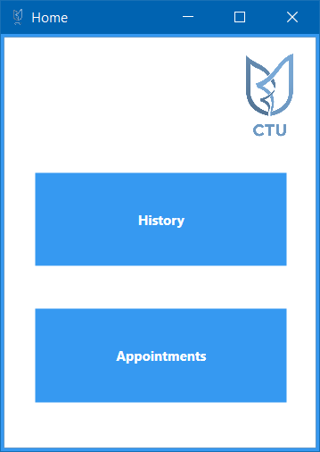

## C#

using System;

using System.Windows;

namespace CTUCare

{

/// <summary>

/// Interaction logic for Home.xaml

/// </summary>

public partial class Home : Window

{

public Home()

{

InitializeComponent();

}

private void btnAppointments_Click(object sender, RoutedEventArgs e)

{

Appointments newApp = new Appointments();

newApp.Show();

this.Close();

}

Appointments openAppointments = new Appointments();

private void btnHistory_Click(object sender, RoutedEventArgs e)

{

try

{

openAppointments.Show();

}

catch (Exception)

{

Appointments openAppointments = new Appointments();

openAppointments.Show();

}

}

}

}

## XAML

<Window x:Class="CTUCare.Home"

xmlns="http://schemas.microsoft.com/winfx/2006/xaml/presentation"

xmlns:x="http://schemas.microsoft.com/winfx/2006/xaml"

xmlns:d="http://schemas.microsoft.com/expression/blend/2008"

xmlns:mc="http://schemas.openxmlformats.org/markup-compatibility/2006"

xmlns:local="clr-namespace:CTUCare"

mc:Ignorable="d"

Title="Home" Height="411.2" Width="300"

Icon="images/Picture5.png" BorderBrush="#FF3699F1" BorderThickness="3">

<Grid>

<Grid.RowDefinitions>

<RowDefinition Height="106*"/>

<RowDefinition Height="127*"/>

<RowDefinition Height="143*"/>

</Grid.RowDefinitions>

<Button x:Name="btnHistory" Content="History" Margin="26,15.4,24,20.8" BorderThickness="2" Background="#FF3699F1" BorderBrush="White" Foreground="White" FontWeight="Bold" Grid.Row="1" Click="btnHistory_Click"/>

<Button x:Name="btnAppointments" Content="Appointments" Margin="26,13.2,24,39" BorderThickness="2" Background="#FF3699F1" BorderBrush="White" Foreground="White" FontWeight="Bold" Grid.Row="2" Click="btnAppointments_Click"/>

<Rectangle HorizontalAlignment="Left" Margin="189,12,0,9.6" Width="99">

<Rectangle.Fill>

<ImageBrush ImageSource="Images/Picture5.png" Stretch="Uniform"/>

</Rectangle.Fill>

</Rectangle>

</Grid>

</Window>

# Add User

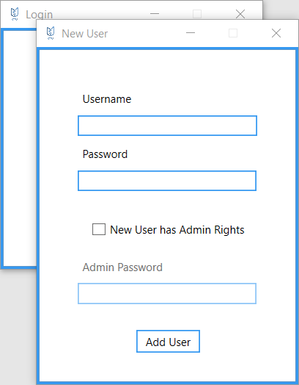

## C#

using System;

using System.Windows;

namespace CTUCare

{

/// <summary>

/// Interaction logic for Home.xaml

/// </summary>

public partial class Home : Window

{

public Home()

{

InitializeComponent();

}

private void btnAppointments_Click(object sender, RoutedEventArgs e)

{

Appointments newApp = new Appointments();

newApp.Show();

this.Close();

}

History openHistory = new History();

private void btnHistory_Click(object sender, RoutedEventArgs e)

{

try

{

openHistory.Show();

}

catch (Exception)

{

History openHistory = new History();

openHistory.Show();

}

this.Close();

}

}

}

## XAML

<Window x:Class="CTUCare.AddUser"

xmlns="http://schemas.microsoft.com/winfx/2006/xaml/presentation"

xmlns:x="http://schemas.microsoft.com/winfx/2006/xaml"

xmlns:d="http://schemas.microsoft.com/expression/blend/2008"

xmlns:mc="http://schemas.openxmlformats.org/markup-compatibility/2006"

xmlns:local="clr-namespace:CTUCare"

mc:Ignorable="d"

Title="New User" Height="404.898" Width="300"

Icon="images/Picture5.png"

ResizeMode="CanMinimize" BorderBrush="#FF3699F1" BorderThickness="3">

<Grid>

<TextBox x:Name="txtUserName" Height="23" Margin="42,71,41.6,0" TextWrapping="Wrap" VerticalAlignment="Top" BorderBrush="#FF3699F1" BorderThickness="1.5"/>

<Label x:Name="label" Content="Username" HorizontalAlignment="Left" Margin="42,40,0,0" VerticalAlignment="Top" Width="83"/>

<Label x:Name="label_Copy" Content="Password" HorizontalAlignment="Left" Margin="42,100,0,0" VerticalAlignment="Top" Width="83"/>

<PasswordBox x:Name="txtPassword" Margin="42,131,42.6,0" VerticalAlignment="Top" RenderTransformOrigin="0.5,0.5" Height="23" BorderBrush="#FF3699F1" BorderThickness="1.5"/>

<Label x:Name="label_Copy1" Content="Admin Password" HorizontalAlignment="Left" Margin="42,223,0,0" VerticalAlignment="Top" Width="101"

IsEnabled="False"/>

<PasswordBox x:Name="txtAPassword" Margin="42,254,42.6,0" VerticalAlignment="Top" RenderTransformOrigin="0.5,0.5" Height="23" BorderBrush="#FF3699F1" BorderThickness="1.5"

IsEnabled="False"/>

<Button x:Name="btnAddUser" Content="Add User" Margin="106,305,104.6,0" VerticalAlignment="Top" BorderBrush="#FF3699F1" BorderThickness="1.5" Background="White" Height="25" Click="btnAddUser_Click"/>

<CheckBox x:Name="checkBox" Content="New User has Admin Rights" HorizontalAlignment="Left" Margin="57,188,0,0" VerticalAlignment="Top" Checked="checkBox_Checked" Unchecked="checkBox_Unchecked"/>

</Grid>

</Window>

# History

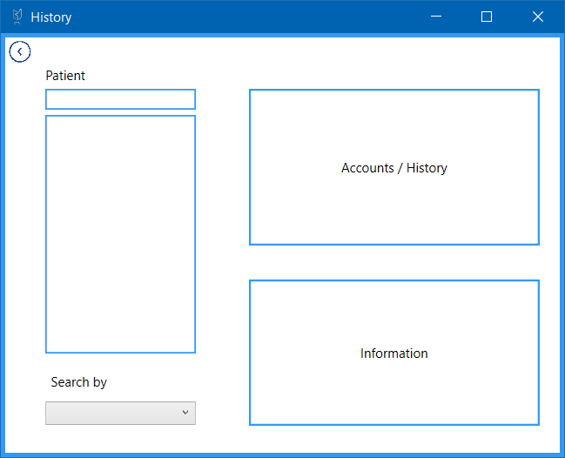

## C#

using System;

using System.Linq;

using System.Windows;

using System.Windows.Controls;

namespace CTUCare

{

/// <summary>

/// Interaction logic for History.xaml

/// </summary>

public partial class History : Window

{

public History()

{

InitializeComponent();

populateList();

}

public static int statementPatient;

private void search()

{

listPatients.Items.Clear();

if (cboxSearchBy.SelectedItem == iName)

{

listPatients.Items.Clear();

foreach (var item in CTUCareDB.Instance.Patients)

{

if (item.Name.ToLower().Contains(searchBox.Text.ToLower()))

{

listPatients.Items.Add(item.Name);

}

}

}

else if (cboxSearchBy.SelectedItem == iSurname)

{

listPatients.Items.Clear();

foreach (var item in CTUCareDB.Instance.Patients)

{

if (item.Name.ToLower().Contains(searchBox.Text.ToLower()))

{

listPatients.Items.Add(item.Surname);

}

}

}

else if (cboxSearchBy.SelectedItem == iIdNo)

{

listPatients.Items.Clear();

foreach (var item in CTUCareDB.Instance.Patients)

{

if (item.IDNumber.Contains(searchBox.Text.ToLower()))

{

listPatients.Items.Add(item.IDNumber);

}

}

}

else if (cboxSearchBy.SelectedItem == iMedicalAidNo)

{

listPatients.Items.Clear();

foreach (var item in CTUCareDB.Instance.Patients)

{

if (item.MedicalAidNo.Contains(searchBox.Text.ToLower()))

{

listPatients.Items.Add(item.MedicalAidNo);

}

}

}

else if (cboxSearchBy.SelectedItem == iAccNo)

{

listPatients.Items.Clear();

foreach (var item in CTUCareDB.Instance.Patients)

{

if (item.AccountNumber.ToString().Contains(searchBox.Text.ToLower()))

{

listPatients.Items.Add(item.AccountNumber);

}

}

}

else if (cboxSearchBy.SelectedItem == iFileNo)

{

listPatients.Items.Clear();

foreach (var item in CTUCareDB.Instance.Patients)

{

if (item.ID.ToString().Contains(searchBox.Text.ToLower()))

{

listPatients.Items.Add(item.ID);

}

}

}

}

private void populateList()

{

listPatients.Items.Clear();

if (cboxSearchBy.SelectedItem == iName)

{

foreach (var item in CTUCareDB.Instance.Patients)

{

listPatients.Items.Add(item.Name);

}

}

else if (cboxSearchBy.SelectedItem == iSurname)

{

foreach (var item in CTUCareDB.Instance.Patients)

{

listPatients.Items.Add(item.Surname);

}

}

else if (cboxSearchBy.SelectedItem == iIdNo)

{

foreach (var item in CTUCareDB.Instance.Patients)

{

listPatients.Items.Add(item.IDNumber);

}

}

else if (cboxSearchBy.SelectedItem == iMedicalAidNo)

{

foreach (var item in CTUCareDB.Instance.Patients)

{

listPatients.Items.Add(item.MedicalAidNo);

}

}

else if (cboxSearchBy.SelectedItem == iAccNo)

{

foreach (var item in CTUCareDB.Instance.Patients)

{

listPatients.Items.Add(item.AccountNumber);

}

}

else if (cboxSearchBy.SelectedItem == iFileNo)

{

foreach (var item in CTUCareDB.Instance.Patients)

{

listPatients.Items.Add(item.ID);

}

}

}

private void setPatient()

{

if (cboxSearchBy.SelectedItem == iName)

{

int user = CTUCareDB.Instance.Patients.Where(x => x.Name == listPatients.SelectedItem.ToString()).FirstOrDefault().ID;

PatientToken.patientID = user;

}

else if (cboxSearchBy.SelectedItem == iSurname)

{

int user = CTUCareDB.Instance.Patients.Where(x => x.Surname == listPatients.SelectedItem.ToString()).FirstOrDefault().ID;

PatientToken.patientID = user;

}

else if (cboxSearchBy.SelectedItem == iIdNo)

{

int user = CTUCareDB.Instance.Patients.Where(x => x.IDNumber == listPatients.SelectedItem.ToString()).FirstOrDefault().ID;

PatientToken.patientID = user;

}

else if (cboxSearchBy.SelectedItem == iMedicalAidNo)

{

int user = CTUCareDB.Instance.Patients.Where(x => x.MedicalAidNo == listPatients.SelectedItem.ToString()).FirstOrDefault().ID;

PatientToken.patientID = user;

}

else if (cboxSearchBy.SelectedItem == iAccNo)

{

int user = CTUCareDB.Instance.Patients.Where(x => x.AccountNumber == Convert.ToInt32(listPatients.SelectedItem.ToString())).FirstOrDefault().ID;

PatientToken.patientID = user;

}

else if (cboxSearchBy.SelectedItem == iFileNo)

{

int user = CTUCareDB.Instance.Patients.Where(x => x.ID == Convert.ToInt32(listPatients.SelectedItem.ToString())).FirstOrDefault().ID;

PatientToken.patientID = user;

}

}

#region Event Methods

private void cboxSearchBy_SelectionChanged(object sender, SelectionChangedEventArgs e)

{

populateList();

}

private void searchBox_TextChanged(object sender, TextChangedEventArgs e)

{

search();

}

Information openInfo = new Information();

private void btnInformation_Click(object sender, RoutedEventArgs e)

{

if (listPatients.SelectedIndex != -1)

{

setPatient();

try

{

openInfo.Show();

}

catch (Exception)

{

Information openInfo = new Information();

openInfo.Show();

}

}

else

{

MessageBox.Show("Please select a patient");

}

}

Accounts HistoryNAccounts = new Accounts();

private void btnAccountsNHistory_Click(object sender, RoutedEventArgs e)

{

if (listPatients.SelectedIndex != -1)

{

statementPatient = CTUCareDB.Instance.Patients.Where(x => x.Name == listPatients.SelectedItem.ToString()).FirstOrDefault().ID;

setPatient();

try

{

HistoryNAccounts.Show();

}

catch (Exception)

{

Accounts HistoryNAccounts = new Accounts();

HistoryNAccounts.Show();

}

}

else

{

MessageBox.Show("Please select a patient");

}

}

private void btnBack_Click(object sender, RoutedEventArgs e)

{

Home goBack = new Home();

goBack.Show();

this.Close();

}

#endregion

}

}

## XAML

<Window x:Class="CTUCare.History"

xmlns="http://schemas.microsoft.com/winfx/2006/xaml/presentation"

xmlns:x="http://schemas.microsoft.com/winfx/2006/xaml"

xmlns:d="http://schemas.microsoft.com/expression/blend/2008"

xmlns:mc="http://schemas.openxmlformats.org/markup-compatibility/2006"

xmlns:local="clr-namespace:CTUCare"

mc:Ignorable="d"

Title="History" Height="427.211" Width="531.773"

Icon="images/Picture5.png" BorderBrush="#FF3699F1" BorderThickness="4">

<Grid>

<ListBox x:Name="listPatients" Margin="37,71,0,0" BorderBrush="#FF3699F1" BorderThickness="1.5" Height="219" VerticalAlignment="Top" Width="138" HorizontalAlignment="Left"/>

<TextBox x:Name="searchBox" Margin="37,47,0,0" TextWrapping="Wrap" BorderBrush="#FF3699F1" BorderThickness="1.5" Height="19" VerticalAlignment="Top" Width="138" HorizontalAlignment="Left" TextChanged="searchBox_TextChanged" />

<Label x:Name="label_Copy3" Content="Patient" HorizontalAlignment="Left" Margin="32,21,0,0" Height="26" VerticalAlignment="Top"/>

<ComboBox x:Name="cboxSearchBy" HorizontalAlignment="Left" Margin="37,334,0,0" VerticalAlignment="Top" Width="138" SelectionChanged="cboxSearchBy_SelectionChanged">

<ComboBoxItem x:Name="iName" Content="Name" HorizontalAlignment="Left" Width="136"/>

<ComboBoxItem x:Name="iSurname" Content="Surname" HorizontalAlignment="Left" Width="136"/>

<ComboBoxItem x:Name="iIdNo" Content="ID Number" HorizontalAlignment="Left" Width="136"/>

<ComboBoxItem x:Name="iMedicalAidNo" Content="Medical Aid Number" HorizontalAlignment="Left" Width="136"/>

<ComboBoxItem x:Name="iAccNo" Content="Account Number" HorizontalAlignment="Left" Width="136"/>

<ComboBoxItem x:Name="iFileNo" Content="File Number" HorizontalAlignment="Left" Width="136"/>

</ComboBox>

<Button x:Name="btnAccountsNHistory" Content="Accounts / History" HorizontalAlignment="Left" Margin="224,47,0,0" VerticalAlignment="Top" Width="267" Height="144" Background="White" BorderBrush="#FF3699F1" BorderThickness="2" Click="btnAccountsNHistory_Click" />

<Button x:Name="btnInformation" Content="Information" HorizontalAlignment="Left" Margin="224,222,0,0" VerticalAlignment="Top" Width="267" Height="135" BorderBrush="#FF3699F1" Background="White" BorderThickness="2" Click="btnInformation_Click"/>

<Label x:Name="label_Copy" Content="Search by" HorizontalAlignment="Left" Margin="37,303,0,0" Height="26" VerticalAlignment="Top"/>

<Button x:Name="btnBack" Content="Button" Foreground="{x:Null}" BorderBrush="{x:Null}" Margin="0,2,0,0" Click="btnBack_Click" HorizontalAlignment="Left" Width="27" Height="22" VerticalAlignment="Top">

<Button.Background>

<ImageBrush ImageSource="Images/Picture1.png" Stretch="Uniform"/>

</Button.Background>

</Button>

</Grid>

</Window>

# Accounts

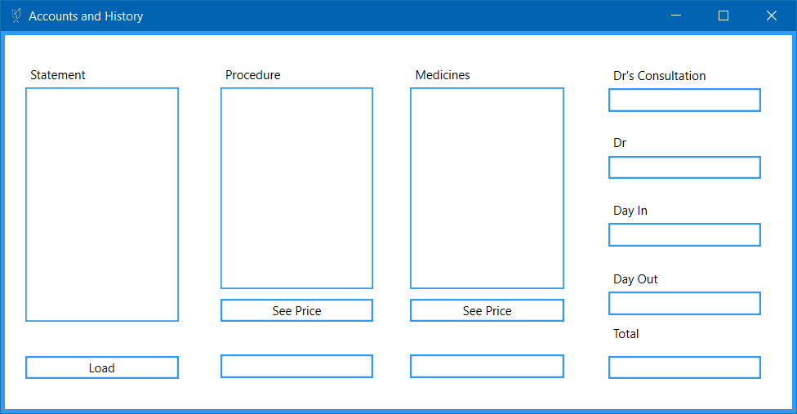

## C#

using System;

using System.Collections.Generic;

using System.Linq;

using System.Windows;

namespace CTUCare

{

/// <summary>

/// Interaction logic for Accounts.xaml

/// </summary>

public partial class Accounts : Window

{

public Accounts()

{

InitializeComponent();

loadStatements();

}

#region Loading Methods

private void loadProPrice()

{

var selectedPro = procedureList.SelectedItem.ToString();

var procedure = CTUCareDB.Instance.Procedures.Where(x => x.Name == selectedPro).FirstOrDefault().Cost;

double money = Convert.ToDouble(procedure);

txtProPrice.Text = "R" + money.ToString();

}

private void loadMediPrice()

{

var selectedMed = medicineList.SelectedItem.ToString();

var medicine = CTUCareDB.Instance.Medicines.Where(x => x.Name == selectedMed).FirstOrDefault().Price;

double money = Convert.ToDouble(medicine);

txtMediPrice.Text = "R" + money.ToString();

}

private void loadStatements()

{

//If dispatch date is null it means that the appointment has not been closed yet and there will be no statement

var statements = CTUCareDB.Instance.Appointments.Where(x => x.PatientID == History.statementPatient).Where(x => x.DispatchDateID != null);

foreach (var item in statements)

{

patientList.Items.Add(item.EntryDate.DateEntered);

}

}

private void loadProcedures()

{

procedureList.Items.Clear();

//Need to find the procedure with a matching entry date and patient ID

var dateID = CTUCareDB.Instance.EntryDates.Where(x => x.DateEntered == date).FirstOrDefault().ID;

var proID = CTUCareDB.Instance.AdministeredProcedures.Where(x => x.EntryDateID == dateID).Where(x => x.PatientID == History.statementPatient).FirstOrDefault().ProcedureID;

var procedure = CTUCareDB.Instance.Procedures.Where(x => x.ID == proID);

foreach (var item in procedure)

{

procedureList.Items.Add(item.Name);

}

procedureList.Items.Refresh();

}

private void loadDayIn()

{

txtDayIn.Text = date.ToShortDateString();

}

private void loadDayOut()

{

var entryDateID = CTUCareDB.Instance.EntryDates.Where(x => x.DateEntered == date).FirstOrDefault().ID;

var dispatchID = CTUCareDB.Instance.Appointments.Where(x => x.PatientID == History.statementPatient).Where(x => x.IntakeDateID == entryDateID).FirstOrDefault().DispatchDateID;

var dispatchD = CTUCareDB.Instance.DispatchDates.Where(x => x.ID == dispatchID).FirstOrDefault().DispatchDate1;

DateTime day = (DateTime)dispatchD;

txtDayOut.Text = day.ToShortDateString();

}

private void loadMedicines()

{

medicineList.Items.Clear();

var dateID = CTUCareDB.Instance.EntryDates.Where(x => x.DateEntered == date).FirstOrDefault().ID;

var medicineID = CTUCareDB.Instance.AdministeredMedicines.Where(x => x.DateAdministeredID == dateID).Where(x => x.PatientID == History.statementPatient).FirstOrDefault().MedicineID;

var medicine = CTUCareDB.Instance.Medicines.Where(x => x.ID == medicineID);

foreach (var item in medicine)

{

medicineList.Items.Add(item.Name);

}

medicineList.Items.Refresh();

}

private void loadDrsPrice()

{

var dateID = CTUCareDB.Instance.EntryDates.Where(x => x.DateEntered == date).FirstOrDefault().ID;

var doctorID = CTUCareDB.Instance.Appointments.Where(x => x.PatientID == History.statementPatient).Where(x => x.IntakeDateID == dateID).FirstOrDefault().DrID;

var doctor = CTUCareDB.Instance.Doctors.Where(x => x.ID == doctorID).FirstOrDefault().ConsultationFee.ToString();

double price = Convert.ToDouble(doctor);

txtDrsConsultation.Text = "R" + price.ToString();

}

private void loadDr()

{

var dateID = CTUCareDB.Instance.EntryDates.Where(x => x.DateEntered == date).FirstOrDefault().ID;

var doctorID = CTUCareDB.Instance.Appointments.Where(x => x.PatientID == History.statementPatient).Where(x => x.IntakeDateID == dateID).FirstOrDefault().DrID;

var doctor = CTUCareDB.Instance.Doctors.Where(x => x.ID == doctorID).FirstOrDefault().Name;

txtDr.Text = doctor;

}

#endregion

#region Event Methods

//Linked to the selected item in the statements list

public static DateTime date;

private void btnLoad_Click(object sender, RoutedEventArgs e)

{

date = (DateTime)patientList.SelectedItem;

loadProcedures();

loadDrsPrice();

loadMedicines();

loadDayIn();

loadDayOut();

calculateTotal();

loadDr();

}

private void btnProPrice_Click(object sender, RoutedEventArgs e)

{

loadProPrice();

}

private void btnMediPrice_Click(object sender, RoutedEventArgs e)

{

loadMediPrice();

}

#endregion

#region Total Calculation Methods

private void calculateTotal()

{

double total = calculateProcedureTotal() + calculateMedicineTotal() + calculateDrsTotal();

txtTotalCost.Text = "R" + total.ToString();

}

private double calculateProcedureTotal()

{

List<string> procedures = new List<string>();

List<decimal> proPrices = new List<decimal>();

foreach (var item in procedureList.Items)

{

procedures.Add(item.ToString());

}

foreach (var item in procedures)

{

proPrices.Add(CTUCareDB.Instance.Procedures.Where(x => x.Name == item).FirstOrDefault().Cost);

}

double procedureTotal = proPrices.Sum(x => Convert.ToDouble(x));

return procedureTotal;

}

private double calculateMedicineTotal()

{

List<string> medicines = new List<string>();

List<decimal> medPrices = new List<decimal>();

foreach (var item in medicineList.Items)

{

medicines.Add(item.ToString());

}

foreach (var item in medicines)

{

medPrices.Add(CTUCareDB.Instance.Medicines.Where(x => x.Name == item).FirstOrDefault().Price);

}

double medicineTotal = medPrices.Sum(x => Convert.ToDouble(x));

return medicineTotal;

}

private double calculateDrsTotal()

{

var dateID = CTUCareDB.Instance.EntryDates.Where(x => x.DateEntered == date).FirstOrDefault().ID;

var doctorID = CTUCareDB.Instance.Appointments.Where(x => x.PatientID == History.statementPatient).Where(x => x.IntakeDateID == dateID).FirstOrDefault().DrID;

var doctor = CTUCareDB.Instance.Doctors.Where(x => x.ID == doctorID).FirstOrDefault().ConsultationFee.ToString();

double price = Convert.ToDouble(doctor);

return price;

}

#endregion

}

}

## XAML

<Window x:Class="CTUCare.Accounts"

xmlns="http://schemas.microsoft.com/winfx/2006/xaml/presentation"

xmlns:x="http://schemas.microsoft.com/winfx/2006/xaml"

xmlns:d="http://schemas.microsoft.com/expression/blend/2008"

xmlns:mc="http://schemas.openxmlformats.org/markup-compatibility/2006"

xmlns:local="clr-namespace:CTUCare"

mc:Ignorable="d"

Title="Accounts and History" Height="411.733" Width="793.333"

Icon="images/Picture5.png" BorderBrush="#FF3699F1" BorderThickness="4">

<Grid>

<ListBox x:Name="patientList" Margin="20,51,0,0" BorderBrush="#FF3699F1" BorderThickness="1.5" Height="230" VerticalAlignment="Top" HorizontalAlignment="Left" Width="150" />

<Label x:Name="label" Content="Statement" HorizontalAlignment="Left" Margin="20,25,0,0" Height="26" VerticalAlignment="Top" Width="150"/>

<ListBox x:Name="procedureList" Margin="211,51,0,0" BorderBrush="#FF3699F1" BorderThickness="1.5" Height="198" VerticalAlignment="Top" HorizontalAlignment="Left" Width="150" />

<Label x:Name="label_Copy" Content="Procedure" HorizontalAlignment="Left" Margin="211,25,0,0" Height="26" VerticalAlignment="Top" Width="87"/>

<TextBox Focusable="False" x:Name="txtProPrice" HorizontalAlignment="Left" Height="23" Margin="211,313,0,0" TextWrapping="Wrap" VerticalAlignment="Top" Width="150" BorderThickness="2" BorderBrush="#FF3699F1"/>

<ListBox x:Name="procedureList_Copy" Margin="397,51,0,0" BorderBrush="#FF3699F1" BorderThickness="1.5" Height="198" VerticalAlignment="Top" HorizontalAlignment="Left" Width="151"/>

<Label x:Name="label_Copy2" Content="Medicines" HorizontalAlignment="Left" Margin="397,25,0,0" Height="26" VerticalAlignment="Top" Width="151"/>

<TextBox Focusable="False" x:Name="txtMediPrice" HorizontalAlignment="Left" Height="23" Margin="397,313,0,0" TextWrapping="Wrap" VerticalAlignment="Top" Width="151" BorderThickness="2" BorderBrush="#FF3699F1"/>

<Label x:Name="label_Copy4" Content="Dr's Consultation" HorizontalAlignment="Left" Margin="591,26,0,0" Height="26" VerticalAlignment="Top" Width="150"/>

<ListBox x:Name="medicineList" Margin="397,51,0,0" BorderBrush="#FF3699F1" BorderThickness="1.5" Height="198" VerticalAlignment="Top" HorizontalAlignment="Left" Width="151" />

<TextBox Focusable="False" x:Name="txtDrsConsultation" HorizontalAlignment="Left" Height="23" Margin="591,52,0,0" TextWrapping="Wrap" VerticalAlignment="Top" Width="150" BorderThickness="2" BorderBrush="#FF3699F1"/>

<Label x:Name="label_Copy5" Content="Day In" HorizontalAlignment="Left" Margin="591,158,0,0" Height="26" VerticalAlignment="Top" Width="150"/>

<TextBox Focusable="False" x:Name="txtDayIn" HorizontalAlignment="Left" Height="23" Margin="591,184,0,0" TextWrapping="Wrap" VerticalAlignment="Top" Width="150" BorderThickness="2" BorderBrush="#FF3699F1"/>

<Label x:Name="label_Copy6" Content="Day Out" HorizontalAlignment="Left" Margin="591,225,0,0" Height="26" VerticalAlignment="Top" Width="150"/>

<TextBox Focusable="False" x:Name="txtDayOut" HorizontalAlignment="Left" Height="23" Margin="591,251,0,0" TextWrapping="Wrap" VerticalAlignment="Top" Width="150" BorderThickness="2" BorderBrush="#FF3699F1"/>

<Label x:Name="label_Copy7" Content="Total" HorizontalAlignment="Left" Margin="591,279,0,0" Height="26" VerticalAlignment="Top" Width="150"/>

<TextBox Focusable="False" x:Name="txtTotalCost" HorizontalAlignment="Left" Height="23" Margin="591,314,0,0" TextWrapping="Wrap" VerticalAlignment="Top" Width="150" BorderThickness="2" BorderBrush="#FF3699F1"/>

<Button x:Name="btnLoad" Content="Load" HorizontalAlignment="Left" Margin="20,314,0,0" VerticalAlignment="Top" Width="150" Height="23" BorderBrush="#FF3699F1" BorderThickness="2" Background="White" Click="btnLoad_Click"/>

<Button x:Name="btnProPrice" Content="See Price" HorizontalAlignment="Left" Margin="211,258,0,0" VerticalAlignment="Top" Width="150" Height="23" BorderBrush="#FF3699F1" BorderThickness="2" Background="White" Click="btnProPrice_Click" />

<Button x:Name="btnMediPrice" Content="See Price" HorizontalAlignment="Left" Margin="397,258,0,0" VerticalAlignment="Top" Width="151" Height="23" BorderBrush="#FF3699F1" BorderThickness="2" Background="White" Click="btnMediPrice_Click" />

<Label x:Name="label_Copy1" Content="Dr" HorizontalAlignment="Left" Margin="591,92,0,0" Height="26" VerticalAlignment="Top" Width="150"/>

<TextBox x:Name="txtDr" HorizontalAlignment="Left" Height="23" Margin="591,118,0,0" TextWrapping="Wrap" VerticalAlignment="Top" Width="150" BorderThickness="2" BorderBrush="#FF3699F1" Focusable="False"/>

</Grid>

</Window>

# Information

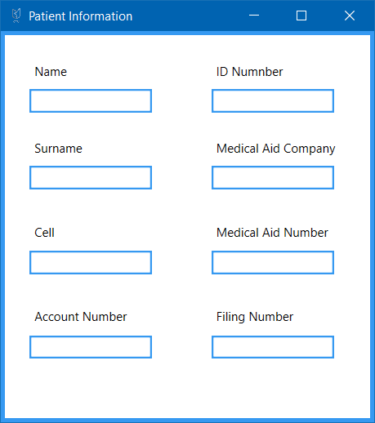

## C#

using System.Linq;

using System.Windows;

namespace CTUCare

{

/// <summary>

/// Interaction logic for Information.xaml

/// </summary>

public partial class Information : Window

{

public Information()

{

InitializeComponent();

loadFields();

}

private void loadFields()

{

txtName.Text = CTUCareDB.Instance.Patients.Where(x => x.ID == PatientToken.patientID).FirstOrDefault().Name;

txtSurname.Text = CTUCareDB.Instance.Patients.Where(x => x.ID == PatientToken.patientID).FirstOrDefault().Surname;

txtIDNo.Text = CTUCareDB.Instance.Patients.Where(x => x.ID == PatientToken.patientID).FirstOrDefault().IDNumber;

txtMedicalAidNo.Text = CTUCareDB.Instance.Patients.Where(x => x.ID == PatientToken.patientID).FirstOrDefault().MedicalAidNo;

txtAccNo.Text = CTUCareDB.Instance.Patients.Where(x => x.ID == PatientToken.patientID).FirstOrDefault().AccountNumber.ToString();

txtCell.Text = CTUCareDB.Instance.Patients.Where(x => x.ID == PatientToken.patientID).FirstOrDefault().Cell;

txtFileNo.Text = PatientToken.patientID.ToString();

var medicID = CTUCareDB.Instance.Patients.Where(x => x.ID == PatientToken.patientID).FirstOrDefault().MedicalAidID;

txtMedicalAidCo.Text = CTUCareDB.Instance.MedicalAids.Where(x => x.ID == medicID).FirstOrDefault().Name;

if (UserType.UserKind == 2)

{

txtAccNo.Visibility = Visibility.Collapsed;

lblAccNo.Visibility = Visibility.Collapsed;

txtCell.Visibility = Visibility.Collapsed;

lblCell.Visibility = Visibility.Collapsed;

txtMedicalAidCo.Visibility = Visibility.Collapsed;

lblMedicalAidCo.Visibility = Visibility.Collapsed;

}

}

}

}

## XAML

<Window x:Class="CTUCare.Information"

xmlns="http://schemas.microsoft.com/winfx/2006/xaml/presentation"

xmlns:x="http://schemas.microsoft.com/winfx/2006/xaml"

xmlns:d="http://schemas.microsoft.com/expression/blend/2008"

xmlns:mc="http://schemas.openxmlformats.org/markup-compatibility/2006"

xmlns:local="clr-namespace:CTUCare"

mc:Ignorable="d"

Title="Patient Information" Height="420.4" Width="380"

Icon="images/Picture5.png" BorderBrush="#FF3699F1" BorderThickness="4">

<Grid>

<TextBox x:Name="txtName" HorizontalAlignment="Left" Height="23" Margin="24,53,0,0" TextWrapping="Wrap" VerticalAlignment="Top" Width="120" BorderBrush="#FF3699F1" Background="White" BorderThickness="2"/>

<Label x:Name="label" Content="Name" HorizontalAlignment="Left" Margin="24,22,0,0" VerticalAlignment="Top"/>

<TextBox x:Name="txtSurname" HorizontalAlignment="Left" Height="23" Margin="24,128,0,0" TextWrapping="Wrap" VerticalAlignment="Top" Width="120" BorderBrush="#FF3699F1" Background="White" BorderThickness="2"/>

<Label x:Name="label_Copy" Content="Surname" HorizontalAlignment="Left" Margin="24,97,0,0" VerticalAlignment="Top"/>

<TextBox x:Name="txtCell" HorizontalAlignment="Left" Height="23" Margin="24,211,0,0" TextWrapping="Wrap" VerticalAlignment="Top" Width="120" BorderBrush="#FF3699F1" Background="White" BorderThickness="2"/>

<TextBox x:Name="txtAccNo" HorizontalAlignment="Left" Height="23" Margin="24,294,0,0" TextWrapping="Wrap" VerticalAlignment="Top" Width="120" BorderBrush="#FF3699F1" Background="White" BorderThickness="2"/>

<Label x:Name="lblCell" Content="Cell" HorizontalAlignment="Left" Margin="24,180,0,0" VerticalAlignment="Top"/>

<TextBox x:Name="txtIDNo" HorizontalAlignment="Left" Height="23" Margin="202,53,0,0" TextWrapping="Wrap" VerticalAlignment="Top" Width="120" BorderBrush="#FF3699F1" Background="White" BorderThickness="2"/>

<Label x:Name="label_Copy2" Content="ID Numnber" HorizontalAlignment="Left" Margin="202,22,0,0" VerticalAlignment="Top"/>

<TextBox x:Name="txtMedicalAidCo" HorizontalAlignment="Left" Height="23" Margin="202,128,0,0" TextWrapping="Wrap" VerticalAlignment="Top" Width="120" BorderBrush="#FF3699F1" Background="White" BorderThickness="2"/>

<Label x:Name="lblMedicalAidCo" Content="Medical Aid Company" HorizontalAlignment="Left" Margin="202,97,0,0" VerticalAlignment="Top"/>

<TextBox x:Name="txtMedicalAidNo" HorizontalAlignment="Left" Height="23" Margin="202,211,0,0" TextWrapping="Wrap" VerticalAlignment="Top" Width="120" BorderBrush="#FF3699F1" Background="White" BorderThickness="2"/>

<Label x:Name="label_Copy4" Content="Medical Aid Number" HorizontalAlignment="Left" Margin="202,180,0,0" VerticalAlignment="Top"/>

<Label x:Name="lblAccNo" Content="Account Number" HorizontalAlignment="Left" Margin="24,262,0,0" VerticalAlignment="Top"/>

<TextBox x:Name="txtFileNo" HorizontalAlignment="Left" Height="23" Margin="202,294,0,0" TextWrapping="Wrap" VerticalAlignment="Top" Width="120" BorderBrush="#FF3699F1" Background="White" BorderThickness="2"/>

<Label x:Name="label_Copy6" Content="Filing Number" HorizontalAlignment="Left" Margin="202,262,0,0" VerticalAlignment="Top"/>

</Grid>

</Window>

# Appointments

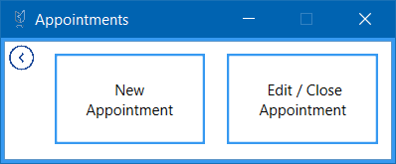

## C#

using System.Windows;

namespace CTUCare

{

/// <summary>

/// Interaction logic for Appointments.xaml

/// </summary>

public partial class Appointments : Window

{

public Appointments()

{

InitializeComponent();

}

NewAppointment newApp = new NewAppointment();

private void btnNewAppointment_Click(object sender, RoutedEventArgs e)

{

NewAppointment newApp = new NewAppointment();

newApp.Show();

this.Close();

}

private void btnCloseAppointment_Click(object sender, RoutedEventArgs e)

{

OpenAppointments openApp = new OpenAppointments();

openApp.Show();

this.Close();

}

private void btnBack_Click(object sender, RoutedEventArgs e)

{

Home goBack = new Home();

goBack.Show();

this.Close();

}

}

}

## XAML

<Window x:Class="CTUCare.Appointments"

xmlns="http://schemas.microsoft.com/winfx/2006/xaml/presentation"

xmlns:x="http://schemas.microsoft.com/winfx/2006/xaml"

xmlns:d="http://schemas.microsoft.com/expression/blend/2008"

xmlns:mc="http://schemas.openxmlformats.org/markup-compatibility/2006"

xmlns:local="clr-namespace:CTUCare"

mc:Ignorable="d"

Title="Appointments" Height="138.462" Width="331.49"

Icon="images/Picture5.png" BorderBrush="#FF3699F1" BorderThickness="3"

ResizeMode="CanMinimize">

<Grid>

<Grid.ColumnDefinitions>

<ColumnDefinition Width="178*"/>

<ColumnDefinition Width="141*"/>

</Grid.ColumnDefinitions>

<Button x:Name="btnNewAppointment" Content=" New &#xA;Appointment" Margin="40,10,12.6,12.4" Background="White" Foreground="Black" BorderBrush="#FF3699F1" BorderThickness="2" Click="btnNewAppointment_Click"/>

<Button x:Name="btnCloseAppointment" Content=" Edit / Close &#xA;Appointment" Margin="5.4,10,10.4,12.4" Background="White" BorderBrush="#FF3699F1" BorderThickness="2" Grid.Column="1" Click="btnCloseAppointment_Click"/>

<Button x:Name="btnBack" Content="Button" Foreground="{x:Null}" BorderBrush="{x:Null}" Margin="0,2,0,0" Click="btnBack_Click" HorizontalAlignment="Left" Width="27" Height="22" VerticalAlignment="Top">

<Button.Background>

<ImageBrush ImageSource="Images/Picture1.png" Stretch="Uniform"/>

</Button.Background>

</Button>

</Grid>

</Window>

# New Appointment

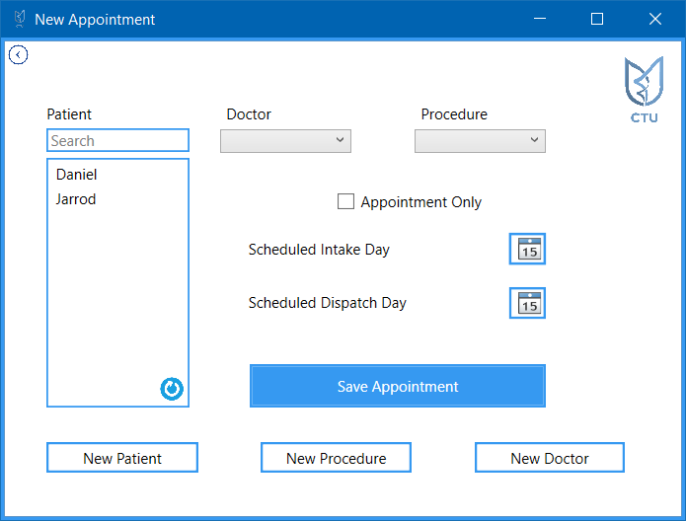

## C#

using System;

using System.Linq;

using System.Windows;

using System.Windows.Controls;

using System.Windows.Media;

namespace CTUCare

{

/// <summary>

/// Interaction logic for NewAppointment.xaml

/// </summary>

public partial class NewAppointment : Window

{

public NewAppointment()

{

InitializeComponent();

populatePatientList();

populateDrBox();

populateProcedureList();

}

private void populatePatientList()

{

Update.updatePatients();

patientList.Items.Clear();

foreach (var item in Update.PatientList)

{

patientList.Items.Add(item.Name);

}

patientList.Items.Refresh();

}

private void populateDrBox()

{

Update.updateDoctors();

cBoxDr.Items.Clear();

foreach (var item in Update.DoctorList)

{

cBoxDr.Items.Add(item.Name);

}

cBoxDr.Items.Refresh();

}

private void populateProcedureList()

{

Update.updateProcedures();

cBoxProcedure.Items.Clear();

foreach (var item in Update.ProcedureList)

{

cBoxProcedure.Items.Add(item.Name);

}

cBoxProcedure.Items.Refresh();

}

private void search()

{

if (searchBox.Text == "")

{

populatePatientList();

}

else

{

patientList.Items.Clear();

foreach (var item in Update.PatientList)

{

if (item.Name.ToLower().Contains(searchBox.Text.ToLower()))

{

patientList.Items.Add(item.Name);

}

}

}

}

#region Event Methods

CTUCareDB db = new CTUCareDB();

//Enables the dispatch options

private void checkBox_Checked(object sender, RoutedEventArgs e)

{

lblDispatch.IsEnabled = false;

dateDispatch.IsEnabled = false;

}

private void checkBox_Unchecked(object sender, RoutedEventArgs e)

{

lblDispatch.IsEnabled = true;

dateDispatch.IsEnabled = true;

}

NewDr newDoc = new NewDr();

private void btnNewDr_Click(object sender, RoutedEventArgs e)

{

try

{

newDoc.Show();

}

catch (Exception)

{

NewDr newDoc = new NewDr();

newDoc.Show();

}

}

NewPatient newPat = new NewPatient();

private void btnNewPatient_Click(object sender, RoutedEventArgs e)

{

try

{

newPat.Show();

}

catch

{

NewPatient newPat = new NewPatient();

newPat.Show();

}

}

NewProcedure newPro = new NewProcedure();

private void btnNewProcedure_Click(object sender, RoutedEventArgs e)

{

try

{

newPro.Show();

}

catch (Exception)

{

NewProcedure newPro = new NewProcedure();

newPro.Show();

}

}

private void searchBox_TextChanged(object sender, TextChangedEventArgs e)

{

search();

}

private void searchBox_GotFocus(object sender, RoutedEventArgs e)

{

searchBox.Foreground = Brushes.Black;

searchBox.Text = "";

}

private void btnSaveAppointment_Click(object sender, RoutedEventArgs e)

{

try

{

var patient = patientList.SelectedItem.ToString();

var appPatient = CTUCareDB.Instance.Patients.Where(x => x.Name == patient).FirstOrDefault();

var doctor = cBoxDr.SelectedItem.ToString();

var appDoctor = CTUCareDB.Instance.Doctors.Where(x => x.Name == doctor).FirstOrDefault();

var procedure = cBoxProcedure.SelectedItem.ToString();

var appProcedure = CTUCareDB.Instance.Procedures.Where(x => x.Name == procedure).FirstOrDefault();

var intakeDate = dateIntake.SelectedDate;

var dispatchDate = dateDispatch.SelectedDate;

EntryDate loadNewEntry = new EntryDate();

Appointment loadNewApp = new Appointment();

AdministeredProcedure loadNewPro = new AdministeredProcedure();

loadNewEntry.PatientID = appPatient.ID;

loadNewEntry.DateEntered = intakeDate;

db.EntryDates.Add(loadNewEntry);

db.SaveChanges();

//Done after entry dates were added so that an ID can be assigned

var entryDate = CTUCareDB.Instance.EntryDates.Where(x => x.PatientID == loadNewEntry.PatientID).ToList();

var entryDateID = entryDate.Last().ID;

loadNewApp.PatientID = appPatient.ID;

loadNewApp.IntakeDateID = entryDateID;

loadNewApp.DrID = appDoctor.ID;

//Only adds if the checkbox is unchecked

if (checkBox.IsChecked == false)

{

loadNewApp.SheduledDispatchDate = (DateTime)dispatchDate;

}

db.Appointments.Add(loadNewApp);

db.SaveChanges();

//Done after appointments to generate an ID

loadNewPro.PatientID = appPatient.ID;

loadNewPro.ProcedureID = appProcedure.ID;

loadNewPro.EntryDateID = entryDateID;

db.AdministeredProcedures.Add(loadNewPro);

db.SaveChanges();

}

catch (Exception)

{

MessageBox.Show("One or more fields still require entries, refer to user manual for more details");

}

Appointments goBack = new Appointments();

goBack.Show();

this.Close();

}

private void cBoxDr_DropDownOpened(object sender, EventArgs e)

{

populateDrBox();

}

private void btnReloadPatients_Click(object sender, RoutedEventArgs e)

{

populatePatientList();

}

#endregion

private void btnBack_Click(object sender, RoutedEventArgs e)

{

Appointments goBack = new Appointments();

goBack.Show();

this.Close();

}

}

}

## XAML

<Window x:Class="CTUCare.NewAppointment"

xmlns="http://schemas.microsoft.com/winfx/2006/xaml/presentation"

xmlns:x="http://schemas.microsoft.com/winfx/2006/xaml"

xmlns:d="http://schemas.microsoft.com/expression/blend/2008"

xmlns:mc="http://schemas.openxmlformats.org/markup-compatibility/2006"

xmlns:local="clr-namespace:CTUCare"

mc:Ignorable="d"

Title="New Appointment" Height="428.8" Width="568.8"

Icon="images/Picture5.png" BorderBrush="#FF3699F1" BorderThickness="3">

<Grid>

<Grid.RowDefinitions>

<RowDefinition Height="73*"/>

<RowDefinition Height="150*"/>

<RowDefinition Height="79*"/>

</Grid.RowDefinitions>

<Grid.ColumnDefinitions>

<ColumnDefinition Width="162*"/>

<ColumnDefinition Width="154*"/>

<ColumnDefinition Width="40*"/>

<ColumnDefinition Width="125*"/>

<ColumnDefinition Width="77*"/>

</Grid.ColumnDefinitions>

<ListBox x:Name="patientList" Margin="34,1.8,9.6,0" BorderBrush="#FF3699F1" BorderThickness="1.5" Grid.Row="1" Height="202" VerticalAlignment="Top" Grid.RowSpan="2"/>

<TextBox x:Name="searchBox" Margin="34,0,9.6,3.2" TextWrapping="Wrap" BorderBrush="#FF3699F1" BorderThickness="1.5" Height="19" VerticalAlignment="Bottom" TextChanged="searchBox_TextChanged" Text="Search" GotFocus="searchBox_GotFocus" Foreground="Gray" />

<Rectangle x:Name="logo" Height="60" Margin="27,10,10.8,0" VerticalAlignment="Top" RenderTransformOrigin="0.44,0.447" Grid.Column="4">

<Rectangle.Fill>

<ImageBrush ImageSource="Images/Picture5.png" Stretch="Uniform"/>

</Rectangle.Fill>

</Rectangle>

<Label x:Name="label" Content="Patient" HorizontalAlignment="Left" Margin="29,0,0,21.8" Height="26" VerticalAlignment="Bottom"/>

<Label x:Name="label_Copy" Content="Doctor" HorizontalAlignment="Left" Margin="15.4,0,0,21.8" Grid.Column="1" Height="26" VerticalAlignment="Bottom"/>

<ComboBox x:Name="cBoxDr" Margin="15.4,0,29.2,2.8" BorderBrush="#FF3699F1" Background="#FF3699F1" Grid.Column="1" Height="19" VerticalAlignment="Bottom" DropDownOpened="cBoxDr_DropDownOpened"/>

<Label x:Name="label_Copy1" Content="Procedure" HorizontalAlignment="Left" Margin="21.8,0,0,21.8" Grid.Column="2" Grid.ColumnSpan="2" Height="26" VerticalAlignment="Bottom"/>

<ComboBox x:Name="cBoxProcedure" Margin="21.8,0,34,2.8" BorderBrush="White" Grid.Column="2" Grid.ColumnSpan="2" Height="19" VerticalAlignment="Bottom"/>

<DatePicker x:Name="dateIntake" Margin="58.8,62.2,34,0" VerticalAlignment="Top" Height="26" BorderBrush="#FF3699F1" BorderThickness="2" Grid.Column="3" Grid.Row="1"/>

<Label x:Name="label_Copy2" Content="Scheduled Intake Day" HorizontalAlignment="Left" Margin="33.4,62,0,0" VerticalAlignment="Top" Grid.Column="1" Grid.ColumnSpan="2" Grid.Row="1"/>

<DatePicker x:Name="dateDispatch" Margin="58.8,106.2,34,0" BorderBrush="#FF3699F1" BorderThickness="2"

IsEnabled="True" Grid.Column="3" Grid.Row="1" Height="26" VerticalAlignment="Top"/>

<Label x:Name="lblDispatch" Content="Scheduled Dispatch Day" HorizontalAlignment="Left" Margin="33.4,105.2,0,0" VerticalAlignment="Top" Width="140"

IsEnabled="True" Grid.Column="1" Grid.ColumnSpan="2" Grid.Row="1"/>

<CheckBox x:Name="checkBox" Content="Appointment Only" Margin="109.4,29.2,0,0" VerticalAlignment="Top" Checked="checkBox_Checked" Unchecked="checkBox_Unchecked" Grid.Column="1" Grid.ColumnSpan="3" Grid.Row="1" HorizontalAlignment="Left" Width="118"/>

<Button x:Name="btnNewPatient" Content="New Patient" Margin="34,40.6,2.6,0" BorderBrush="#FF3699F1" BorderThickness="2" Background="White" Grid.Row="2" Height="25" VerticalAlignment="Top" Click="btnNewPatient_Click"/>

<Button x:Name="btnNewProcedure" Content="New Procedure" Margin="48.4,40.6,20.2,0" BorderBrush="#FF3699F1" BorderThickness="2" Background="White" Grid.Column="1" Grid.ColumnSpan="2" Grid.Row="2" Click="btnNewProcedure_Click" Height="25" VerticalAlignment="Top"/>

<Button x:Name="btnNewDr" Content="New Doctor" Margin="30.8,40.6,45.8,0" BorderBrush="#FF3699F1" BorderThickness="2" Background="White" Grid.Column="3" Grid.ColumnSpan="2" Grid.Row="2" Click="btnNewDr_Click" Height="25" VerticalAlignment="Top"/>

<Button x:Name="btnSaveAppointment" Content="Save Appointment" Margin="39.4,168.8,34,0" BorderBrush="#FF3699F1" BorderThickness="2" Background="#FF3699F1" Grid.ColumnSpan="3" Grid.Row="1" Height="35" VerticalAlignment="Top" Foreground="White" Grid.Column="1" Grid.RowSpan="2" Click="btnSaveAppointment_Click"/>

<Button x:Name="btnReloadPatients" Content="" HorizontalAlignment="Left" Height="24" Margin="122,176.8,0,0" Grid.Row="1" VerticalAlignment="Top" Width="27" BorderBrush="{x:Null}" Foreground="{x:Null}" Grid.RowSpan="2" Click="btnReloadPatients_Click">

<Button.Background>

<ImageBrush ImageSource="Images/reload_icon.jpg" Stretch="Uniform"/>

</Button.Background>

</Button>

<Button x:Name="btnBack" Content="Button" Foreground="{x:Null}" BorderBrush="{x:Null}" Margin="-5,2,0,73.2" Click="btnBack_Click" HorizontalAlignment="Left" Width="32">

<Button.Background>

<ImageBrush ImageSource="Images/Picture1.png" Stretch="Uniform"/>

</Button.Background>

</Button>

</Grid>

</Window>

# Open Appointments

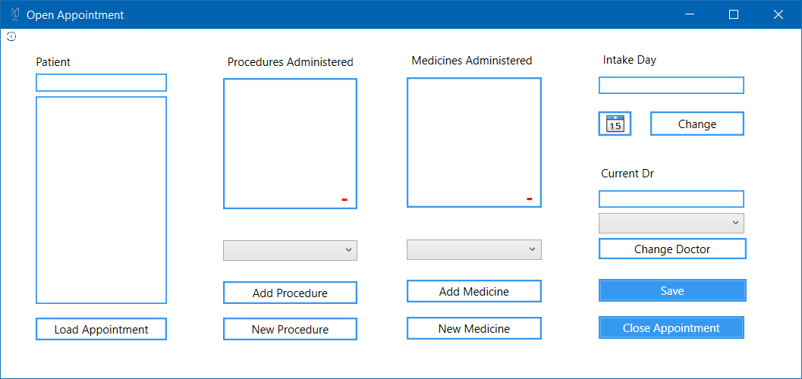

## C#

using System;

using System.Collections.Generic;

using System.Linq;

using System.Windows;

namespace CTUCare

{

/// <summary>

/// Interaction logic for OpenAppointments.xaml

/// </summary>

public partial class OpenAppointments : Window

{

public OpenAppointments()

{

InitializeComponent();

updateProcedureBox();

updatePatientsAppointments();

updateMedicineBox();

updateDrs();

}

public int currentPatient;

private void setDate()

{

var intakeDatum = CTUCareDB.Instance.Appointments.Where(x => x.PatientID == currentPatient).FirstOrDefault().IntakeDateID;

var selectedDate = CTUCareDB.Instance.EntryDates.Where(x => x.ID == intakeDatum).FirstOrDefault().DateEntered;

txtCurrentDay.Text = selectedDate.ToString();

dateIntake.SelectedDate = selectedDate;

}

private void goBack()

{

Appointments goBack = new Appointments();

goBack.Show();

this.Close();

}

private void saveNewDate()

{

var intakeDatum = CTUCareDB.Instance.Appointments.Where(x => x.PatientID == currentPatient).FirstOrDefault().IntakeDateID;

DispatchDate newExitDate = new DispatchDate();

newExitDate.PatientID = currentPatient;

newExitDate.DispatchDate1 = DateTime.Now;

CTUCareDB.Instance.DispatchDates.Add(newExitDate);

CTUCareDB.Instance.SaveChanges();

var lookupDate = CTUCareDB.Instance.DispatchDates.Where(x => x.PatientID == currentPatient).ToList();

CTUCareDB.Instance.Appointments.Where(x => x.EntryDate.ID == intakeDatum).Where(x => x.PatientID == currentPatient).FirstOrDefault().DispatchDateID = lookupDate.LastOrDefault().ID;

CTUCareDB.Instance.SaveChanges();

}

#region Update/Loading Methods

public void updateProcedureBox()

{

Update.updateProcedures();

cboxProcedures.Items.Clear();

foreach (var item in Update.ProcedureList)

{

cboxProcedures.Items.Add(item.Name);

}

cboxProcedures.Items.Refresh();

}

public void updateMedicineBox()

{

Update.updateMedicines();

cboxMedicines.Items.Clear();

foreach (var item in Update.MedicineList)

{

cboxMedicines.Items.Add(item.Name);

}

cboxMedicines.Items.Refresh();

}

private void updateDrs()

{

cboxDrs.Items.Clear();

Update.updateDoctors();

foreach (var item in Update.DoctorList)

{

cboxDrs.Items.Add(item.Name);

}

cboxDrs.Items.Refresh();

}

private void updateDate()

{

var intakeDatum = CTUCareDB.Instance.Appointments.Where(x => x.PatientID == currentPatient).FirstOrDefault().IntakeDateID;

CTUCareDB.Instance.EntryDates.Remove(CTUCareDB.Instance.EntryDates.Where(x => x.ID == intakeDatum).FirstOrDefault());

EntryDate updatedDate = new EntryDate();

updatedDate.ID = (int)intakeDatum;

updatedDate.PatientID = currentPatient;

updatedDate.DateEntered = dateIntake.SelectedDate;

CTUCareDB.Instance.EntryDates.Add(updatedDate);

}

private void updatePatientsAppointments()

{

List<Appointment> openAppointments = new List<Appointment>();

var Appointments = CTUCareDB.Instance.Appointments.Where(x => x.DispatchDate == null);

foreach (var item in Appointments)

{

openAppointments.Add(item);

}

foreach (var item in openAppointments)

{

listPatients.Items.Add(item.Patient.Name);

}

}

private void loadDoctor()

{

var intakeDatum = CTUCareDB.Instance.Appointments.Where(x => x.PatientID == currentPatient).FirstOrDefault().IntakeDateID;

txtCurrentDoc.Text = CTUCareDB.Instance.Appointments.Where(x => x.IntakeDateID == intakeDatum).FirstOrDefault().Doctor.Name;

}

private void updateMedicinesList()

{

try

{

listMedicinesAdmin.Items.Clear();

List<AdministeredMedicine> appliedMedicines = new List<AdministeredMedicine>();

var appMedicines = CTUCareDB.Instance.AdministeredMedicines.Where(x => x.PatientID == currentPatient).FirstOrDefault().DateAdministeredID;

var currentMeds = CTUCareDB.Instance.AdministeredMedicines.Where(x => x.DateAdministeredID == appMedicines).ToList();

foreach (var item in currentMeds)

{

listMedicinesAdmin.Items.Add(item.Medicine.Name);

}

listMedicinesAdmin.Items.Refresh();

}

catch (Exception)

{

}

}

private void updateProcedureList()

{

listProceduresAdmin.Items.Clear();

List<AdministeredProcedure> appliedProcedures = new List<AdministeredProcedure>();

var appProcedures = CTUCareDB.Instance.AdministeredProcedures.Where(x => x.PatientID == currentPatient).FirstOrDefault().EntryDateID;

var currentProcedures = CTUCareDB.Instance.AdministeredProcedures.Where(x => x.EntryDateID == appProcedures).ToList();

foreach (var item in currentProcedures)

{

listProceduresAdmin.Items.Add(item.Procedure.Name);

}

listProceduresAdmin.Items.Refresh();

}

private void saveProcedures()

{

var appProcedures = CTUCareDB.Instance.AdministeredProcedures.Where(x => x.PatientID == currentPatient).FirstOrDefault().EntryDateID;

var currentProcedures = CTUCareDB.Instance.AdministeredProcedures.Where(x => x.EntryDateID == appProcedures).ToList();

foreach (var item in currentProcedures)

{

Update.AdminProcedureList.Remove(item);

}

}

#endregion

#region Event Methods

private void btnChangeDoctor_Click(object sender, RoutedEventArgs e)

{

var intakeDatum = CTUCareDB.Instance.Appointments.Where(x => x.PatientID == currentPatient).FirstOrDefault().IntakeDateID;

CTUCareDB.Instance.Appointments.Where(x => x.IntakeDateID == intakeDatum).FirstOrDefault().DrID =

CTUCareDB.Instance.Doctors.Where(x => x.Name == cboxDrs.SelectedItem.ToString()).FirstOrDefault().ID;

txtCurrentDoc.Text = cboxDrs.SelectedItem.ToString();

}

private void btnCloseApp_Click(object sender, RoutedEventArgs e)

{

saveNewDate();

goBack();

}

private void btnChangeDate_Click(object sender, RoutedEventArgs e)

{

updateDate();

txtCurrentDay.Text = dateIntake.SelectedDate.ToString();

}

private void btnSave_Click(object sender, RoutedEventArgs e)

{

CTUCareDB.Instance.SaveChanges();

goBack();

}

private void btnLoadAppointment_Click(object sender, RoutedEventArgs e)

{

currentPatient = CTUCareDB.Instance.Patients.Where(x => x.Name == listPatients.SelectedItem.ToString()).FirstOrDefault().ID;

updateMedicinesList();

updateProcedureList();

loadDoctor();

setDate();

}

NewMedicine newMed = new NewMedicine();

private void btnNewMedicine_Click(object sender, RoutedEventArgs e)

{

try

{

newMed.Show();

}

catch (Exception)

{

NewMedicine newMed = new NewMedicine();

newMed.Show();

}

}

NewProcedure newPro = new NewProcedure();

private void btnNewProcedure_Click(object sender, RoutedEventArgs e)

{

try

{

newPro.Show();

}

catch (Exception)

{

NewProcedure newPro = new NewProcedure();

newPro.Show();

}

}

private void btnAddProcedure_Click(object sender, RoutedEventArgs e)

{

listProceduresAdmin.Items.Add(cboxProcedures.SelectedItem);

AdministeredProcedure newAdminPro = new AdministeredProcedure();

var intakeDatum = CTUCareDB.Instance.Appointments.Where(x => x.PatientID == currentPatient).FirstOrDefault().IntakeDateID;

newAdminPro.PatientID = currentPatient;

newAdminPro.ProcedureID = CTUCareDB.Instance.Procedures.Where(x => x.Name == cboxProcedures.SelectedItem.ToString()).FirstOrDefault().ID;

newAdminPro.EntryDateID = intakeDatum;

CTUCareDB.Instance.AdministeredProcedures.Add(newAdminPro);

}

private void btnRemoveProcedure_Click(object sender, RoutedEventArgs e)

{

var selected = listProceduresAdmin.SelectedItem;

listProceduresAdmin.Items.Remove(listProceduresAdmin.SelectedItem);

CTUCareDB.Instance.AdministeredProcedures.Remove(CTUCareDB.Instance.AdministeredProcedures.Where

(x => x.Procedure.Name == selected.ToString()).FirstOrDefault());

}

private void cboxProcedures_DropDownOpened(object sender, EventArgs e)

{

updateProcedureBox();

cboxProcedures.Items.Refresh();

}

private void cboxMedicines_DropDownOpened(object sender, EventArgs e)

{

updateMedicineBox();

cboxMedicines.Items.Refresh();

}

private void btnAddMedicine_Click(object sender, RoutedEventArgs e)

{

listMedicinesAdmin.Items.Add(cboxMedicines.SelectedItem);

AdministeredMedicine newAdminMedicine = new AdministeredMedicine();

var intakeDatum = CTUCareDB.Instance.Appointments.Where(x => x.PatientID == currentPatient).FirstOrDefault().IntakeDateID;

newAdminMedicine.PatientID = currentPatient;

newAdminMedicine.MedicineID = CTUCareDB.Instance.Medicines.Where(x => x.Name == cboxMedicines.SelectedItem.ToString()).FirstOrDefault().ID;

newAdminMedicine.DateAdministeredID = intakeDatum;

CTUCareDB.Instance.AdministeredMedicines.Add(newAdminMedicine);

}

private void btnRemoveMedicine_Click(object sender, RoutedEventArgs e)

{

var selected = listMedicinesAdmin.SelectedItem;

CTUCareDB.Instance.AdministeredMedicines.Remove(CTUCareDB.Instance.AdministeredMedicines.Where

(x => x.Medicine.Name == selected.ToString()).FirstOrDefault());

listMedicinesAdmin.Items.Remove(listMedicinesAdmin.SelectedItem);

}

private void cboxDrs_DropDownOpened(object sender, EventArgs e)

{

updateDrs();

}

#endregion

private void btnBack_Click(object sender, RoutedEventArgs e)

{

Appointments goBack = new Appointments();

goBack.Show();

this.Close();

}

}

}

## XAML

<Window x:Class="CTUCare.OpenAppointments"

xmlns="http://schemas.microsoft.com/winfx/2006/xaml/presentation"

xmlns:x="http://schemas.microsoft.com/winfx/2006/xaml"

xmlns:d="http://schemas.microsoft.com/expression/blend/2008"

xmlns:mc="http://schemas.openxmlformats.org/markup-compatibility/2006"

xmlns:local="clr-namespace:CTUCare"

mc:Ignorable="d"

Title="Open Appointment" Height="406.767" Width="858.773"

Icon="images/Picture5.png">

<Grid>

<Grid.RowDefinitions>

<RowDefinition/>

</Grid.RowDefinitions>

<Grid.ColumnDefinitions>

<ColumnDefinition/>

</Grid.ColumnDefinitions>

<ListBox x:Name="listProceduresAdmin" Margin="234,52,0,0" HorizontalAlignment="Left" Width="142" BorderBrush="#FF3699F1" BorderThickness="2" Height="138" VerticalAlignment="Top"/>

<ComboBox x:Name="cboxProcedures" Margin="234,223,0,0" DropDownOpened="cboxProcedures_DropDownOpened" HorizontalAlignment="Left" Width="142" Height="22" VerticalAlignment="Top" />

<Button x:Name="btnAddProcedure" Content="Add Procedure" Margin="234,266,0,0" BorderBrush="#FF3699F1" BorderThickness="2" Background="White" Click="btnAddProcedure_Click" HorizontalAlignment="Left" Width="142" Height="24" VerticalAlignment="Top" />

<Button x:Name="btnNewProcedure" Content="New Procedure" Margin="234,305,0,0" BorderBrush="#FF3699F1" BorderThickness="2" Background="White" Click="btnNewProcedure_Click" HorizontalAlignment="Left" Width="142" Height="24" VerticalAlignment="Top" />

<Label x:Name="label" Content="Procedures Administered" Margin="234,21,0,0" VerticalAlignment="Top" Height="26" HorizontalAlignment="Left" Width="142"/>

<Label x:Name="label_Copy2" Content="Intake Day" Margin="0,19,126,0" VerticalAlignment="Top" Height="26" HorizontalAlignment="Right" Width="88"/>

<ListBox x:Name="listMedicinesAdmin" Margin="0,51,274,0" HorizontalAlignment="Right" Width="142" BorderThickness="2" BorderBrush="#FF3699F1" Height="138" VerticalAlignment="Top"/>

<Label x:Name="label_Copy" Content="Medicines Administered" Margin="0,20,278,0" VerticalAlignment="Top" Height="26" HorizontalAlignment="Right" Width="138"/>

<ComboBox x:Name="cboxMedicines" Margin="0,222,274,0" HorizontalAlignment="Right" Width="142" DropDownOpened="cboxMedicines_DropDownOpened" Height="22" VerticalAlignment="Top"/>

<Button x:Name="btnAddMedicine" Content="Add Medicine" Margin="0,265,274,0" BorderBrush="#FF3699F1" BorderThickness="2" Background="White" Click="btnAddMedicine_Click" HorizontalAlignment="Right" Width="142" Height="24" VerticalAlignment="Top" />

<Button x:Name="btnNewMedicine" Content="New Medicine" Margin="0,304,274,0" BorderBrush="#FF3699F1" BorderThickness="2" Background="White" Click="btnNewMedicine_Click" HorizontalAlignment="Right" Width="142" Height="24" VerticalAlignment="Top" />

<DatePicker x:Name="dateIntake" Margin="0,87,179,0" VerticalAlignment="Top" Height="26" BorderBrush="#FF3699F1" BorderThickness="2" HorizontalAlignment="Right" Width="35"/>

<ComboBox x:Name="cboxDrs" Margin="0,194,60,0" VerticalAlignment="Top" Height="22" DropDownOpened="cboxDrs_DropDownOpened" HorizontalAlignment="Right" Width="154"/>

<Button x:Name="btnChangeDoctor" Content="Change Doctor" Margin="0,221,58,0" BorderBrush="#FF3699F1" BorderThickness="2" Background="White" Height="22" VerticalAlignment="Top" HorizontalAlignment="Right" Width="156" Click="btnChangeDoctor_Click" />

<Button x:Name="btnSave" Content="Save" Margin="0,264,58,0" BorderBrush="#FF3699F1" BorderThickness="2" Background="#FF3699F1" Foreground="White" HorizontalAlignment="Right" Width="156" Height="24" VerticalAlignment="Top" Click="btnSave_Click" />

<Button x:Name="btnCloseApp" Content="Close Appointment" Margin="0,303,60,0" BorderBrush="#FF3699F1" BorderThickness="2" Background="#FF3699F1" Foreground="White" HorizontalAlignment="Right" Width="154" Height="24" VerticalAlignment="Top" Click="btnCloseApp_Click" />

<Label x:Name="label_Copy1" Content="Current Dr" Margin="0,139,118,0" VerticalAlignment="Top" Height="26" HorizontalAlignment="Right" Width="98"/>

<Button x:Name="btnRemoveProcedure" Content="-" HorizontalAlignment="Left" Margin="355,162,0,0" VerticalAlignment="Top" Width="15" RenderTransformOrigin="-0.455,0.396" BorderBrush="White" Background="White" Foreground="Red" FontWeight="Bold" FontSize="20" Height="23" Click="btnRemoveProcedure_Click"/>

<Button x:Name="btnRemoveMedicine" Content="-" HorizontalAlignment="Right" Margin="0,161,279,0" VerticalAlignment="Top" Width="15" RenderTransformOrigin="-0.455,0.396" BorderBrush="White" Background="White" Foreground="Red" FontWeight="Bold" FontSize="20" Height="23" Click="btnRemoveMedicine_Click"/>

<ListBox x:Name="listPatients" Margin="37,71,0,0" BorderBrush="#FF3699F1" BorderThickness="1.5" Height="219" VerticalAlignment="Top" HorizontalAlignment="Left" Width="138"/>

<TextBox x:Name="searchBox" Margin="37,47,0,0" TextWrapping="Wrap" BorderBrush="#FF3699F1" BorderThickness="1.5" Height="19" VerticalAlignment="Top" HorizontalAlignment="Left" Width="138" />

<Label x:Name="label_Copy3" Content="Patient" Margin="32,21,0,0" Height="26" VerticalAlignment="Top" HorizontalAlignment="Left" Width="46"/>

<Button x:Name="btnLoadAppointment" Content="Load Appointment" Margin="37,305,0,0" BorderBrush="#FF3699F1" BorderThickness="2" Background="White" HorizontalAlignment="Left" Width="138" Click="btnLoadAppointment_Click" Height="24" VerticalAlignment="Top" />

<TextBox x:Name="txtCurrentDoc" Margin="0,170,60,0" TextWrapping="Wrap" BorderBrush="#FF3699F1" BorderThickness="1.5" Height="19" VerticalAlignment="Top" Width="154" HorizontalAlignment="Right" Focusable="False"/>

<TextBox x:Name="txtCurrentDay" Margin="0,50,60,0" TextWrapping="Wrap" BorderBrush="#FF3699F1" BorderThickness="1.5" Height="19" VerticalAlignment="Top" Width="154" HorizontalAlignment="Right" Focusable="False"/>

<Button x:Name="btnChangeDate" Content="Change" Margin="0,87,60,0" BorderBrush="#FF3699F1" BorderThickness="2" Background="White" Height="26" VerticalAlignment="Top" HorizontalAlignment="Right" Width="99" Click="btnChangeDate_Click" />

<Button x:Name="btnBack" Content="Button" Foreground="{x:Null}" BorderBrush="{x:Null}" Margin="-5,2,0,354.8" Click="btnBack_Click" HorizontalAlignment="Left" Width="32">

<Button.Background>

<ImageBrush ImageSource="Images/Picture1.png" Stretch="Uniform"/>

</Button.Background>

</Button>

</Grid>

</Window>

# New Patient

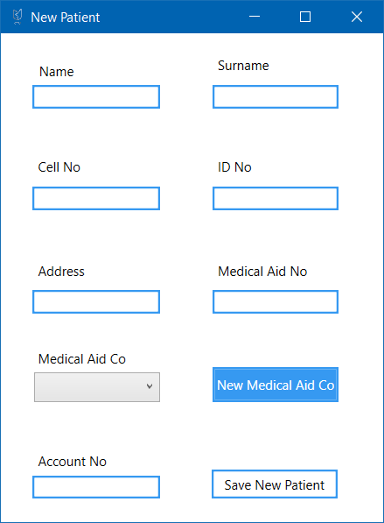

## C#

using System;

using System.Linq;

using System.Windows;

namespace CTUCare

{

/// <summary>

/// Interaction logic for NewPatient.xaml

/// </summary>

public partial class NewPatient : Window

{

public NewPatient()

{

InitializeComponent();

updateMedicCompanies();

}

NewMedicalAidCo newMed = new NewMedicalAidCo();

private void btnNewMedicalAid_Click(object sender, RoutedEventArgs e)

{

try

{

newMed.Show();

}

catch (Exception)

{

NewMedicalAidCo newMed = new NewMedicalAidCo();

newMed.Show();

}

updateMedicCompanies();

}

private void updateMedicCompanies()

{

Update.updateCompanies();

cboxMedicalAidCo.Items.Clear();

foreach (var item in Update.MedicalAidCoList)

{

cboxMedicalAidCo.Items.Add(item.Name);

}

}

private void cboxMedicalAidCo_DropDownOpened(object sender, EventArgs e)

{

updateMedicCompanies();

cboxMedicalAidCo.Items.Refresh();

}

private void btnSaveNew_Click(object sender, RoutedEventArgs e)

{

try

{

string name = txtName.Text;

string surname = txtSurname.Text;

string cellNo = txtCell.Text;

string idNo = txtIDNo.Text;

string address = txtAdd.Text;

string medicalAidNo = txtMedicalAidNo.Text;

string medicalAidCo = cboxMedicalAidCo.SelectedItem.ToString();

int accNo = Convert.ToInt32(txtAccNo.Text);

Patient newPatient = new Patient

{

Name = name,

Surname = surname,

Cell = cellNo,

IDNumber = idNo,

Address = address,

MedicalAidNo = medicalAidNo,

MedicalAidID = CTUCareDB.Instance.MedicalAids.Where(x => x.Name == medicalAidCo).FirstOrDefault().ID,

AccountNumber = accNo,

};

CTUCareDB.Instance.Patients.Add(newPatient);

CTUCareDB.Instance.SaveChanges();

this.Close();

}

catch (Exception)

{

MessageBox.Show("One or more values are still invalid or missing");

}

}

}

}

## XAML

<Window x:Class="CTUCare.NewPatient"

xmlns="http://schemas.microsoft.com/winfx/2006/xaml/presentation"

xmlns:x="http://schemas.microsoft.com/winfx/2006/xaml"

xmlns:d="http://schemas.microsoft.com/expression/blend/2008"

xmlns:mc="http://schemas.openxmlformats.org/markup-compatibility/2006"

xmlns:local="clr-namespace:CTUCare"

mc:Ignorable="d"

Title="New Patient" Height="483.6" Width="364.03"

Icon="images/Picture5.png">

<Grid>

<Grid.RowDefinitions>

<RowDefinition Height="93*"/>

<RowDefinition Height="96*"/>

<RowDefinition Height="91*"/>

<RowDefinition Height="88*"/>

<RowDefinition Height="85*"/>

</Grid.RowDefinitions>

<Grid.ColumnDefinitions>

<ColumnDefinition Width="172*"/>

<ColumnDefinition Width="185*"/>

</Grid.ColumnDefinitions>

<TextBox x:Name="txtName" Margin="29,47,23,22.8" TextWrapping="Wrap" BorderBrush="#FF3699F1" BorderThickness="2"/>

<TextBox x:Name="txtSurname" Margin="25,47,40.6,22.8" TextWrapping="Wrap" BorderBrush="#FF3699F1" BorderThickness="2" Grid.Column="1"/>

<TextBox x:Name="txtCell" Margin="29,48.2,23,24.8" TextWrapping="Wrap" BorderBrush="#FF3699F1" BorderThickness="2" Grid.Row="1"/>

<TextBox x:Name="txtIDNo" Margin="25,48.2,40.6,24.8" TextWrapping="Wrap" BorderBrush="#FF3699F1" BorderThickness="2" Grid.Column="1" Grid.Row="1"/>

<TextBox x:Name="txtAdd" Margin="29,48.2,23,20" TextWrapping="Wrap" BorderBrush="#FF3699F1" BorderThickness="2" Grid.Row="2"/>

<TextBox x:Name="txtMedicalAidNo" Margin="25,48.2,40.6,20" TextWrapping="Wrap" BorderBrush="#FF3699F1" BorderThickness="2" Grid.Column="1" Grid.Row="2"/>

<Button x:Name="btnNewMedicalAid" Content="New Medical Aid Co" Margin="25,29,40.6,26" Background="#FF3699F1" BorderBrush="#FF3699F1" BorderThickness="2" Foreground="White" Grid.Column="1" Grid.Row="3" Click="btnNewMedicalAid_Click"/>

<Label x:Name="label_Copy" Content="Medical Aid Co" HorizontalAlignment="Left" Margin="29,8,0,0" VerticalAlignment="Top" Grid.Row="3"/>

<ComboBox x:Name="cboxMedicalAidCo" Margin="30,34,23,26" Grid.Row="3" DropDownOpened="cboxMedicalAidCo_DropDownOpened"/>

<Button x:Name="btnSaveNew" Content="Save New Patient" Margin="24,36,41.6,21.6" Background="White" BorderBrush="#FF3699F1" BorderThickness="2" Grid.Row="4" Click="btnSaveNew_Click" Grid.Column="1"/>

<Label x:Name="label_Copy1" Content="Medical Aid No" HorizontalAlignment="Left" Margin="25,17.2,0,0" VerticalAlignment="Top" Grid.Column="1" Grid.Row="2"/>

<Label x:Name="label_Copy2" Content="Address" HorizontalAlignment="Left" Margin="29,17.2,0,0" VerticalAlignment="Top" Grid.Row="2"/>

<Label x:Name="label_Copy3" Content="ID No" HorizontalAlignment="Left" Margin="25,17.2,0,0" VerticalAlignment="Top" Grid.Column="1" Grid.Row="1"/>

<Label x:Name="label_Copy4" Content="Cell No" HorizontalAlignment="Left" Margin="29,17.2,0,0" VerticalAlignment="Top" Grid.Row="1"/>

<Label x:Name="label_Copy5" Content="Surname" HorizontalAlignment="Left" Margin="25,16,0,0" VerticalAlignment="Top" Grid.Column="1"/>

<Label x:Name="label_Copy6" Content="Name" HorizontalAlignment="Left" Margin="30,21,0,0" VerticalAlignment="Top"/>

<TextBox x:Name="txtAccNo" Margin="29,41,23,21.6" TextWrapping="Wrap" BorderBrush="#FF3699F1" BorderThickness="2" Grid.Row="4"/>

<Label x:Name="label_Copy7" Content="Account No" HorizontalAlignment="Left" Margin="29,15,0,0" VerticalAlignment="Top" Grid.Row="4"/>

</Grid>

</Window>

# New Procedure

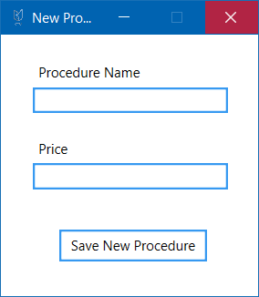

## C#

using System;

using System.Linq;

using System.Windows;

namespace CTUCare

{

/// <summary>

/// Interaction logic for NewProcedure.xaml

/// </summary>

public partial class NewProcedure : Window

{

public NewProcedure()

{

InitializeComponent();

}

CTUCareDB db = new CTUCareDB();

private void btnSaveNew_Click(object sender, RoutedEventArgs e)

{

if (txtName.Text.Count() > 0)

{

try

{

Procedure newPro = new Procedure

{

Name = txtName.Text,

Cost = Decimal.Parse(txtPrice.Text),

};

db.Procedures.Add(newPro);

db.SaveChanges();

Update.updateProcedures();

this.Close();

}

catch (Exception)

{

MessageBox.Show("Please enter a monetary value");

}

}

else

{

MessageBox.Show("Please enter a valid name");

}

}

}

}

## XAML

<Window x:Class="CTUCare.NewProcedure"

xmlns="http://schemas.microsoft.com/winfx/2006/xaml/presentation"

xmlns:x="http://schemas.microsoft.com/winfx/2006/xaml"

xmlns:d="http://schemas.microsoft.com/expression/blend/2008"

xmlns:mc="http://schemas.openxmlformats.org/markup-compatibility/2006"

xmlns:local="clr-namespace:CTUCare"

mc:Ignorable="d"

Title="New Procedure" Height="267.2" Width="240"

Icon="images/Picture5.png"

ResizeMode="CanMinimize">

<Grid>

<TextBox x:Name="txtName" Margin="28,46,26.6,0" TextWrapping="Wrap" BorderBrush="#FF3699F1" BorderThickness="2" Height="23" VerticalAlignment="Top"/>

<Label x:Name="label" Content="Procedure Name" HorizontalAlignment="Left" Margin="28,20,0,0" VerticalAlignment="Top"/>

<TextBox x:Name="txtPrice" Margin="28,113,26.6,0" TextWrapping="Wrap" BorderBrush="#FF3699F1" BorderThickness="2" Height="23" VerticalAlignment="Top"/>

<Label x:Name="label_Copy" Content="Price" HorizontalAlignment="Left" Margin="28,87,0,0" VerticalAlignment="Top"/>

<Button x:Name="btnSaveNew" Content="Save New Procedure" Margin="51,171,44.6,0" Background="White" BorderBrush="#FF3699F1" BorderThickness="2" Height="28" VerticalAlignment="Top" Click="btnSaveNew_Click"/>

</Grid>

</Window>

# New Medicine

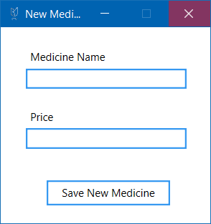

## C#

using System;

using System.Linq;

using System.Windows;

namespace CTUCare

{

/// <summary>

/// Interaction logic for NewMedicine.xaml

/// </summary>

public partial class NewMedicine : Window

{

public NewMedicine()

{

InitializeComponent();

}

CTUCareDB db = new CTUCareDB();

private void btnSaveNew_Click(object sender, RoutedEventArgs e)

{

if (txtName.Text.Count() > 0)

{

try

{

Medicine newMedi = new Medicine

{

Name = txtName.Text,

Price = Decimal.Parse(txtPrice.Text),

};

db.Medicines.Add(newMedi);

db.SaveChanges();

Update.updateMedicines();

this.Close();

}

catch (Exception)

{

MessageBox.Show("Please enter a monetary value");

}

}

else

{

MessageBox.Show("Please enter a valid name");

}

}

}

}

## XAML

<Window x:Class="CTUCare.NewMedicine"

xmlns="http://schemas.microsoft.com/winfx/2006/xaml/presentation"

xmlns:x="http://schemas.microsoft.com/winfx/2006/xaml"

xmlns:d="http://schemas.microsoft.com/expression/blend/2008"

xmlns:mc="http://schemas.openxmlformats.org/markup-compatibility/2006"

xmlns:local="clr-namespace:CTUCare"

mc:Ignorable="d"

Title="New Medicine" Height="256.667" Width="247.778"

Icon="images/Picture5.png"

ResizeMode="CanMinimize">

<Grid>

<TextBox x:Name="txtName" Margin="28,46,0,0" TextWrapping="Wrap" BorderBrush="#FF3699F1" BorderThickness="2" Height="23" VerticalAlignment="Top" HorizontalAlignment="Left" Width="179"/>

<Label x:Name="label" Content="Medicine Name" HorizontalAlignment="Left" Margin="28,20,0,0" VerticalAlignment="Top"/>

<TextBox x:Name="txtPrice" Margin="28,113,0,0" TextWrapping="Wrap" BorderBrush="#FF3699F1" BorderThickness="2" Height="23" VerticalAlignment="Top" HorizontalAlignment="Left" Width="179"/>

<Label x:Name="label_Copy" Content="Price" HorizontalAlignment="Left" Margin="28,87,0,0" VerticalAlignment="Top"/>

<Button x:Name="btnSaveNew" Content="Save New Medicine" Margin="51,171,0,0" Background="White" BorderBrush="#FF3699F1" BorderThickness="2" Height="28" VerticalAlignment="Top" HorizontalAlignment="Left" Width="138" Click="btnSaveNew_Click"/>

</Grid>

</Window>

# New Doctor

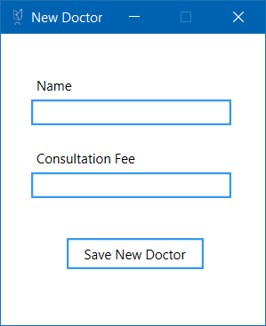

## C#

using System;

using System.Linq;

using System.Windows;

namespace CTUCare

{

/// <summary>

/// Interaction logic for NewMedicine.xaml

/// </summary>

public partial class NewMedicine : Window

{

public NewMedicine()

{

InitializeComponent();

}

CTUCareDB db = new CTUCareDB();

private void btnSaveNew_Click(object sender, RoutedEventArgs e)

{

if (txtName.Text.Count() > 0)

{

try

{

Medicine newMedi = new Medicine

{

Name = txtName.Text,

Price = Decimal.Parse(txtPrice.Text),

};

db.Medicines.Add(newMedi);

db.SaveChanges();

Update.updateMedicines();

this.Close();

}

catch (Exception)

{

MessageBox.Show("Please enter a monetary value");

}

}

else

{

MessageBox.Show("Please enter a valid name");

}

}

}

}

# New Medical Aid Company

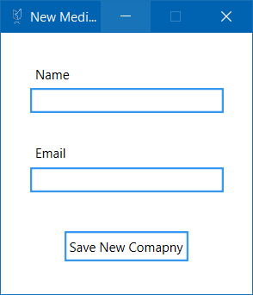

## C#

using System;

using System.Linq;

using System.Windows;

namespace CTUCare

{

/// <summary>

/// Interaction logic for NewMedicine.xaml

/// </summary>

public partial class NewMedicine : Window

{

public NewMedicine()

{

InitializeComponent();

}

CTUCareDB db = new CTUCareDB();

private void btnSaveNew_Click(object sender, RoutedEventArgs e)

{

if (txtName.Text.Count() > 0)

{

try

{

Medicine newMedi = new Medicine

{

Name = txtName.Text,

Price = Decimal.Parse(txtPrice.Text),

};

db.Medicines.Add(newMedi);

db.SaveChanges();

Update.updateMedicines();

this.Close();

}

catch (Exception)

{

MessageBox.Show("Please enter a monetary value");

}

}

else

{

MessageBox.Show("Please enter a valid name");

}

}

}

}

## XAML

<Window x:Class="CTUCare.NewMedicalAidCo"

xmlns="http://schemas.microsoft.com/winfx/2006/xaml/presentation"

xmlns:x="http://schemas.microsoft.com/winfx/2006/xaml"

xmlns:d="http://schemas.microsoft.com/expression/blend/2008"

xmlns:mc="http://schemas.openxmlformats.org/markup-compatibility/2006"

xmlns:local="clr-namespace:CTUCare"

mc:Ignorable="d"

Title="New Medical Aid Company" Height="280" Width="247.778"

Icon="images/Picture5.png"

ResizeMode="CanMinimize">

<Grid>

<TextBox x:Name="txtName" Margin="27,51,26.6,0" TextWrapping="Wrap" BorderBrush="#FF3699F1" BorderThickness="2" Height="23" VerticalAlignment="Top"/>

<Label x:Name="label" Content="Name" HorizontalAlignment="Left" Margin="27,25,0,0" VerticalAlignment="Top"/>

<TextBox x:Name="txtEmail" Margin="27,125,26.6,0" TextWrapping="Wrap" BorderBrush="#FF3699F1" BorderThickness="2" Height="23" VerticalAlignment="Top"/>

<Label x:Name="label_Copy" Content="Email" HorizontalAlignment="Left" Margin="27,98,0,0" VerticalAlignment="Top"/>

<Button x:Name="btnSaveNew" Content="Save New Comapny" Margin="59,184,59.6,0" Background="White" BorderBrush="#FF3699F1" BorderThickness="2" Height="28" VerticalAlignment="Top"/>

</Grid>

</Window>

# PatientToken.cs

namespace CTUCare

{

//Used to carry information from one window to another about the patient

public static class PatientToken

{

public static string patientName;

public static int patientID;

}

}

# Update.cs

using System.Collections.Generic;

namespace CTUCare

{

public static class Update

{

/* These lists are updated using the methods below */

public static List<Procedure> ProcedureList = new List<Procedure>();

public static List<Medicine> MedicineList = new List<Medicine>();

public static List<Doctor> DoctorList = new List<Doctor>();

public static List<Patient> PatientList = new List<Patient>();

public static List<AdministeredProcedure> AdminProcedureList = new List<AdministeredProcedure>();

public static List<MedicalAid> MedicalAidCoList = new List<MedicalAid>();

/* These methods are used to update comboboxes/listboxes and anything that contains items

throughout the application. They are static so they can be accessed anywhere */

#region Methods

public static void updateCompanies()

{

MedicalAidCoList.Clear();

foreach (var item in CTUCareDB.Instance.MedicalAids)

{

MedicalAidCoList.Add(item);

}

}

public static void updateProcedures()

{

ProcedureList.Clear();

foreach (var item in CTUCareDB.Instance.Procedures)

{

ProcedureList.Add(item);

}

}

public static void updateAdminProcedures()

{

AdminProcedureList.Clear();

foreach (var item in CTUCareDB.Instance.AdministeredProcedures)

{

AdminProcedureList.Add(item);

}

}

public static void updateMedicines()

{

MedicineList.Clear();

foreach (var item in CTUCareDB.Instance.Medicines)

{

MedicineList.Add(item);

}

}

public static void updateDoctors()

{

DoctorList.Clear();

foreach (var item in CTUCareDB.Instance.Doctors)

{

DoctorList.Add(item);

}

}

public static void updatePatients()

{

PatientList.Clear();

foreach (var item in CTUCareDB.Instance.Patients)

{

PatientList.Add(item);

}

}

#endregion

}

}

# UserType.cs

namespace CTUCare

{

public static class UserType

{

//Used as a token to enable and disable features

public static int UserKind;

}

}

# Database Diagram

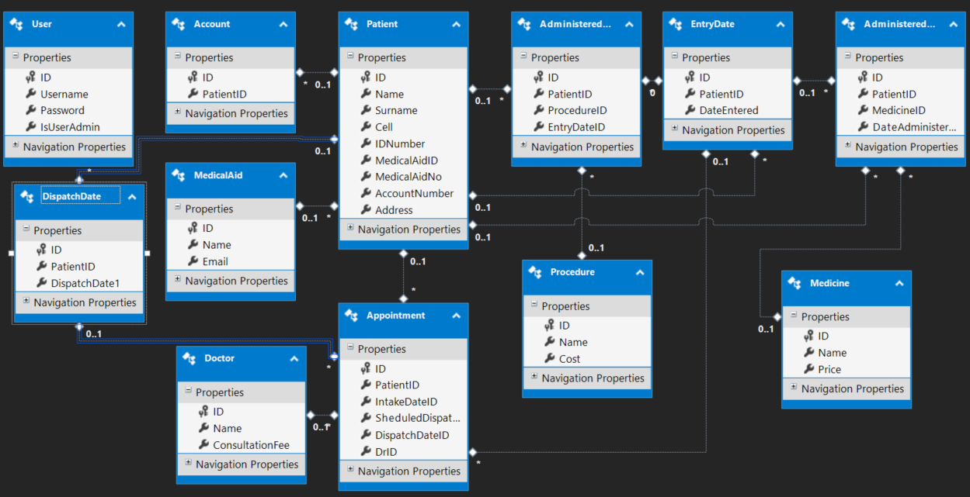

# Error Report

## Error 1

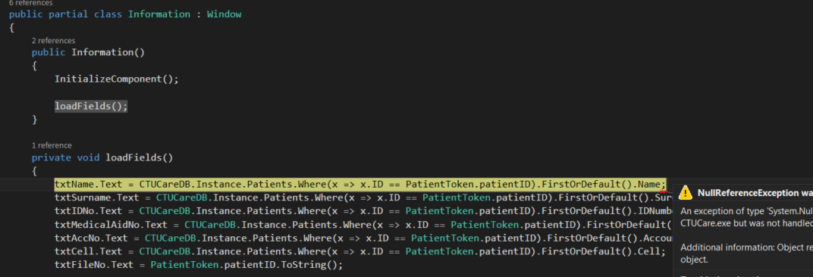

When loading the login (2nd page to appear when starting the application), the complier initializes the window without me requesting this

## Solution 1

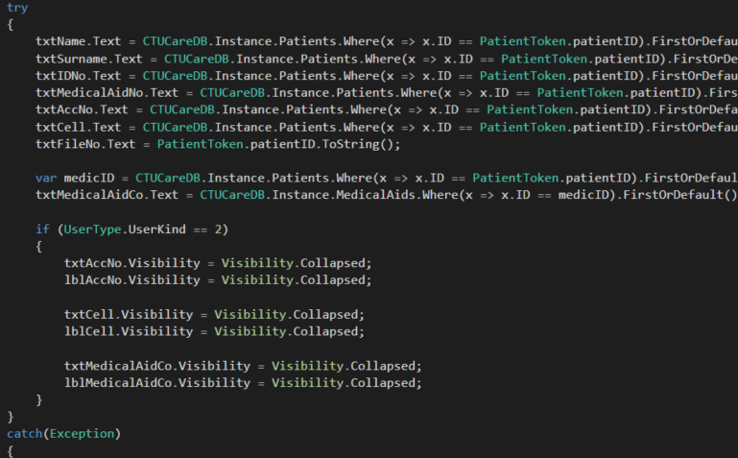

Placed the loadFields() method inside of a try block with an empty catch

## Error 2

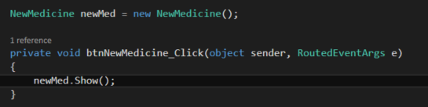

I was getting double instances of windows when launching them like this

## Solution 2

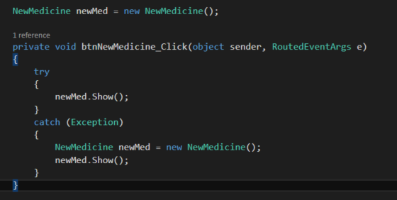

Similarly to the last solution I placed the code block inside try catch block that re-initializes the window if it has been closed

## Error 3

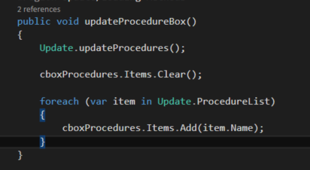

Every now and comboboxes and listboxes would not update their items when event triggers were called

## Solution 3

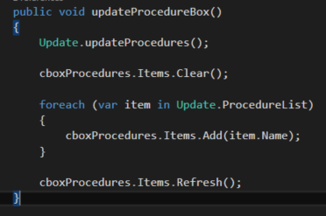

I simply refreshed the items of whatever box I was trying to update

# Conclusion

Unfortunately, the sheer size of the programme made it more and more difficult to follow a plan as the layout evolved along the way. Many originally planned features did come through, however other key features were integrated together and changed drastically from what was set out

The appointment system evolved the most as expected and was the main feature of the application in the end. One can assume this is due to the fact that no strict constraints were to be followed